**Quantization Error:** Quantization error, also known as quantization noise or quantization distortion, is the difference between the actual analogy signal's value and the digital representation it is quantized to. This error is introduced because the analogy signal can fall anywhere within a continuous range, but it is approximated by one of the discrete values available in the digital system. The quantization error can be positive or negative, depending on whether the analogy value is closer to the upper or lower boundary of the quantization interval.

**Using the MATLAB function ‘quant’, use the code above to design your own quantise.**

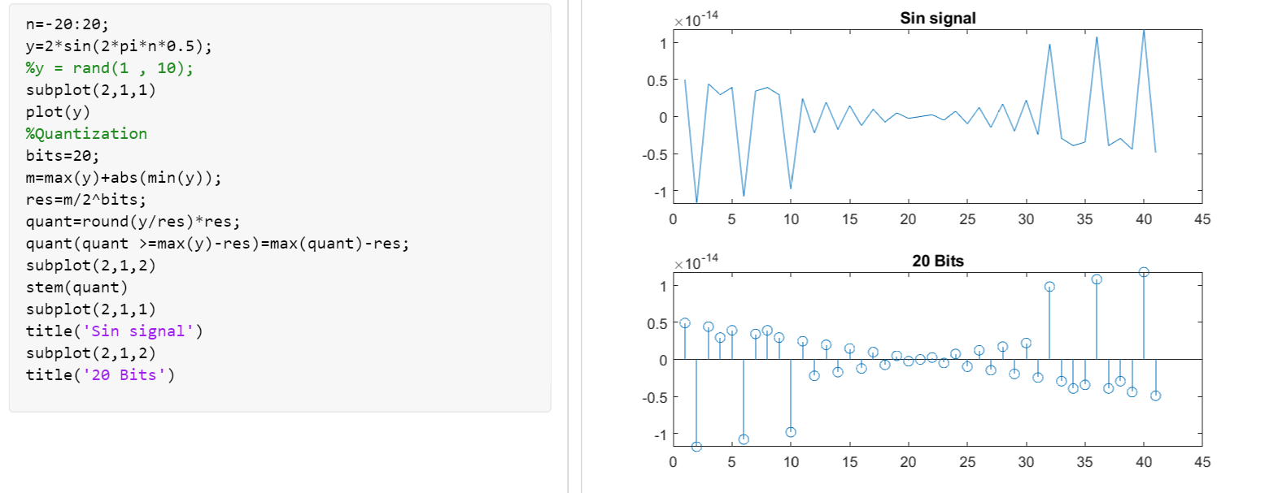

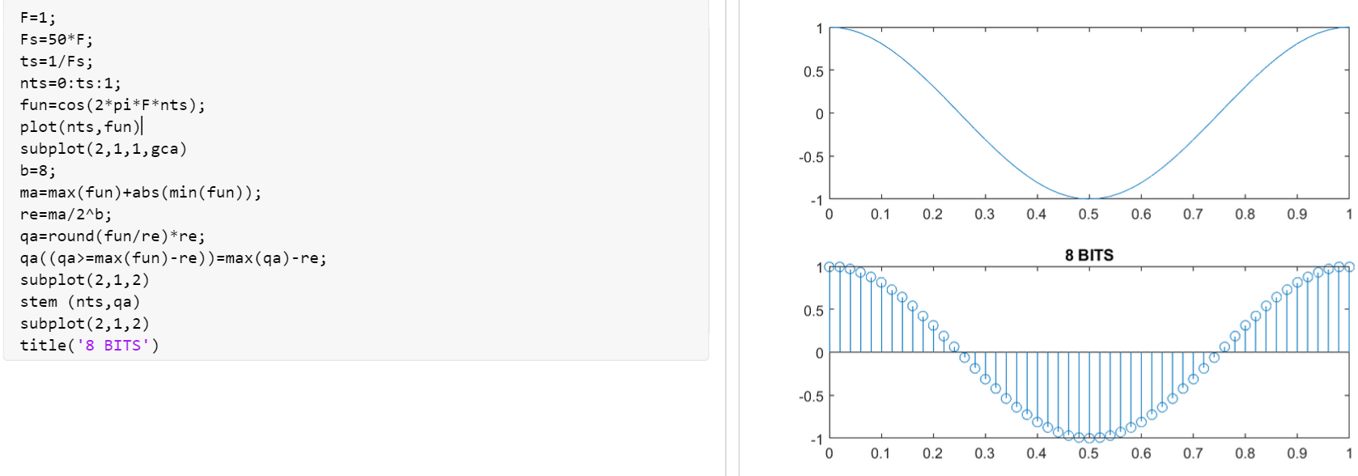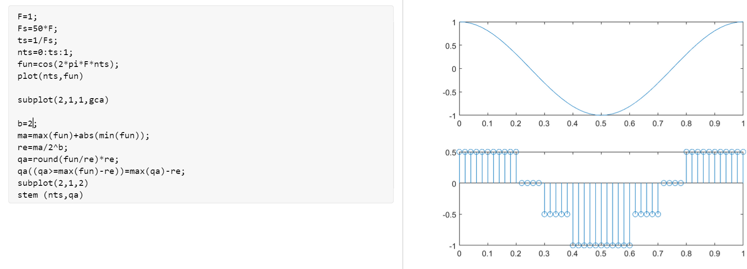

Change the number of bits of the quantise and observe the output signal. Discuss the effect on the quantisation error?

2 bits